# Creating Custom Field “At Home?”

Custom Fields can be created in Settings > Custom Field:

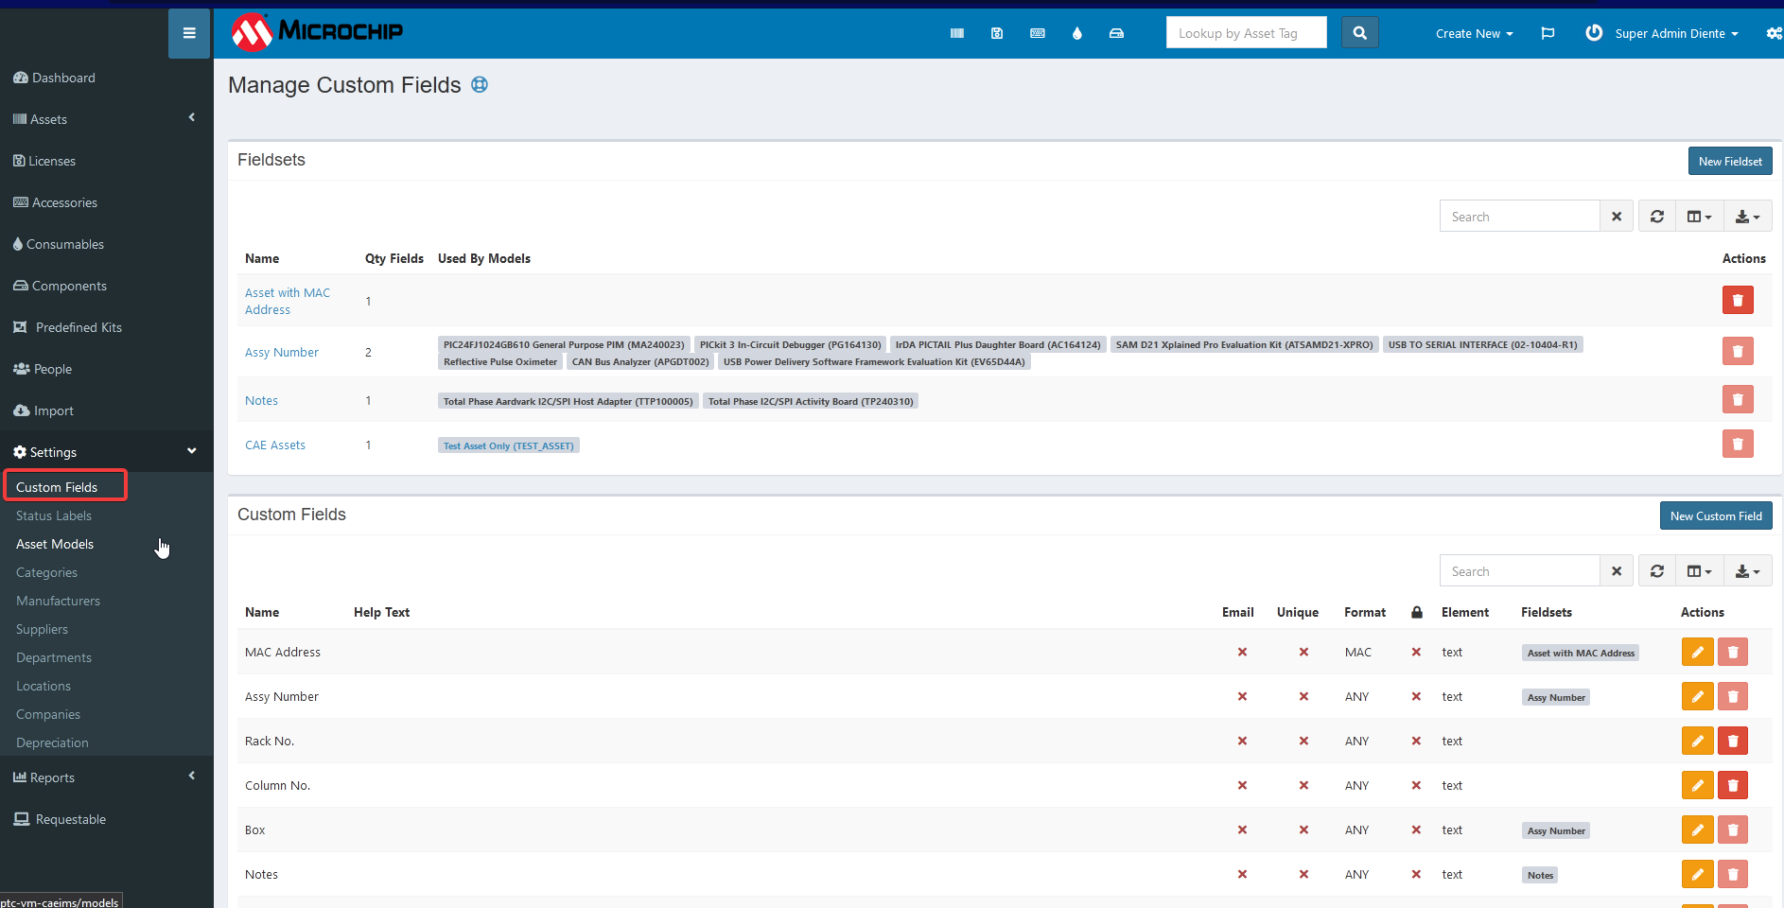

# Creating Custom Fieldset “CAE Assets”

A Custom Fieldset should be created to include the custom field. “At Home?” custom field is included in “CAE Assets” fieldset.

Add ‘At Home?” field in “CAE Assets”.

Note: Required means needed to be filled-up so “At home?” is not required. Can be changed in the future.

# Tagging Assets with “At Home?” attribute

Initial Setup:

* CAE needs to audit all the assets that are “at home”.
* CAE needs to update their “All Assets” view.

Flow:

1. After checking out, CAE should modify this field.
2. After checking in, CAE should remove check on this field.

Disadvantages:

* Additional steps.
* Can be forgotten to update the field and then carried after checking in the asset back to the inventory.
* Not automatically updated after checking in.